Day Project - https://www.youtube.com/playlist?list=PLe1T0uBrDrfOYE8OwQvooPjmnP1zY3wFe

Start Date - Jan 11, 2019

Completion Date -

Introduction: This project will explain simple integration of Kafka - Spark - NO SQL - Visualisation.

Architecture:

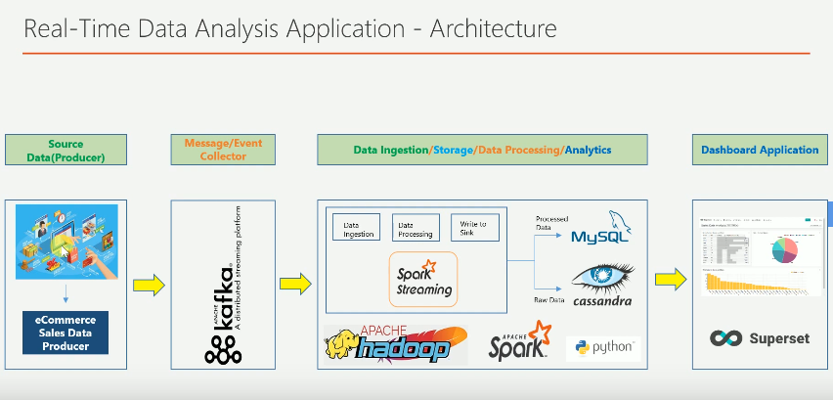

Required Software:

* Cloudera QuickStart
* Kafka
* Anaconda
* Spark 2
* Cassandra
* Superset

**Environment Setup:**

Step-1 Download Cloudera QuickStart

Step-2 Download Kafka and Install Kafka on Cloudera Quickstart

Step-3 Download and install Anaconda

Step-4 Download and Install Spark2

Step-5 Download and Install Cassandra

Step-6 Download and Install Superset

Python Code:

